ASSIGNMENT 7

CONSTRUCTORS AND CLASS

/*

Q1 Write a program that uses a class where the member functions are defined outside a

class.

*/

#include <iostream>

using namespace std;

class Example

{

int val;

public:

//function declarations

void init_val(int v);

void print_val();

};

//function definitions

void Example::init_val(int v)

{

val=v;

}

void Example::print_val()

{

cout<<"----------------------------------\n";

cout<<"The value is : "<<val<<endl;

cout<<"----------------------------------\n";

}

int main()

{

//create object

Example Ex;

Ex.init_val(100);

Ex.print_val();

return 0;

}

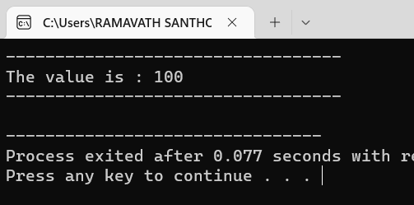

/* Q2 Try with local and global objects (with same program Q1)*/

#include <iostream>

using namespace std;

class Example

{

private:

int val;

public:

//function declarations

void init_val(int v);

void print_val();

};

//function definitions

void Example::init_val(int v)

{

val=v;

}

void Example::print_val()

{

cout<<"----------------------------------\n";

cout<<"The value is : "<<val<<endl;

cout<<"----------------------------------\n";

}

Example obj; // global object

int main()

{

//create object

Example Ex; //local obj

cout << "\nBy using LOCAL OBJECT"<<endl;

Ex.init_val(999);

Ex.print_val();

cout << "\nBy using GLOBAL OBJECT"<<endl;

obj.init_val(785);

obj.print_val();

return 0;

}

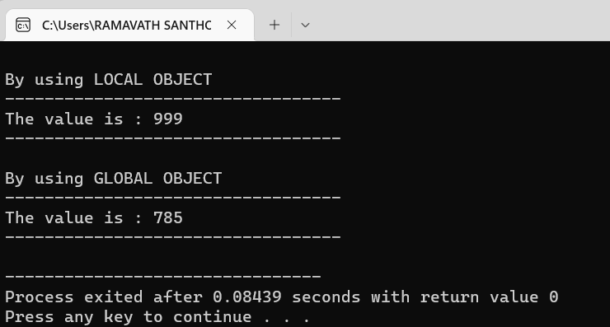

/*

Q3 Try with different constructors and definition inside &amp; outside of the class (with same

program Q1)

*/

#include <iostream>

using namespace std;

class Example

{

private:

int val;

public:

//constructor declarations

Example()

{

val = 0;

}

Example(int);

void print_val();

};

//constructor definitions

Example :: Example(int v)

{

val=v;

}

void Example::print_val()

{

cout<<"----------------------------------\n";

cout<<"The value is : "<<val<<endl;

cout<<"----------------------------------\n";

}

Example obj; // global object

int main()

{

//create object

cout << "\nParameterized constructor"<<endl;

Example Ex(99); //local obj

Ex.print_val();

cout << "\nDefault Constructor"<<endl;

Example obj;

obj.print_val();

return 0;

}

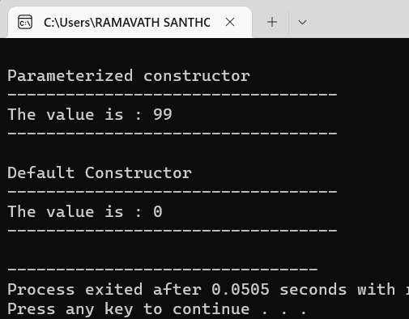

/*

Q4) Try with distractor (with same program Q1)

*/

#include <iostream>

using namespace std;

class Example

{

private:

int val;

public:

//constructor declarations

Example()

{

val = 0;

}

Example(int);

~Example();

};

//constructor definitions

Example :: Example(int v)

{

val=v;

}

Example :: ~Example()

{

cout<<"\nval: "<<val<<endl;

if(val == 100)

cout << "\nDestructor for parameterized constructor"<<endl;

if(val == 0)

cout << "\nDestructor for Default consructor"<<endl;

}

int main()

{

//create object

Example Ex(100); //local obj

Example obj;

return 0;

}

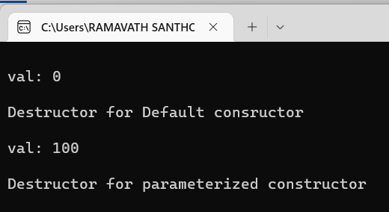

/*

Q5) Write a program in C++ to convert a decimal number into binary without using an

array and using the constructor and destructor.

*/

#include <iostream>

using namespace std;

class dec_to_bin

{

public:

dec_to_bin()

{

int p=1,bin=0,n;

cout<<"Enter Decimal number : ";

cin>>n;

while(n)

{

bin += (n%2)*p;

p=p*10;

n=n/2;

}

cout<<"binary number = "<< bin;

}

~dec_to_bin()

{

cout << "\nDecimal to Binary Converted";

}

};

int main()

{

dec_to_bin obj;

return 0;

}

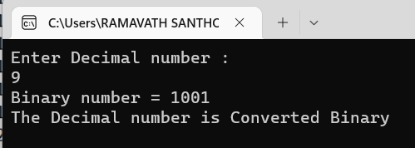

/*

Q6) Write a program in C++ to print Floyd’s Triangle by using the constructor destructor.

*/

#include<iostream>

using namespace std;

class Floyds_Triangle

{

public:

int i,n,j,p = 1;

//constructor

Floyds_Triangle()

{

cout<<"\n Enter the number of rows : ";

cin>>n;

for(i=1;i<=n;i++)

{

for(j=1;j<=i;j++)

{

cout<< p << " ";

p++;

}

cout << endl;

}

}

~Floyds_Triangle() // destructor

{

cout << "\n***********Floyds Triangle Printed**********";

}

};

int main()

{

Floyds_Triangle obj;

return 0;

}

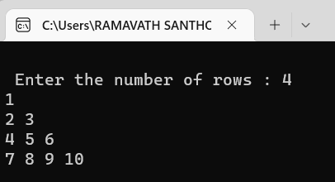

/*

Q7) Let’s see the C++ program to show the Sum of n number of odd natural numbers by

using the different type of constructors.

*/

#include<iostream>

using namespace std;

class Sum_Constructor

{

private :

int i,n,num1 ,num2;

public :

Sum_Constructor(int a)

{

n=a;

int sum=0;

for(int i=1;i<=n;i++)

{

cout<<"The output is:"<<endl;

cout<<2*i-1<<" ";

sum=sum+(2*i-1);

cout<<endl;

}

cout<<"The sum of the given input = "<<sum<<endl;

}

Sum_Constructor(int a,int b)

{

cout<<"For 1st Input Answer is Given below"<<endl;

num1 = a;

int sum1=0;

for(int i=1;i<=num1 ;i++)

{

cout<<"The output is:";

cout<<2*i-1<<" ";

sum1=sum1+(2*i-1);

cout<<endl;

}

cout<<"The sum of the given input = "<<sum1<<endl;

cout<<endl;

cout<<"For 2nd Input Answer is Given below."<<endl;

num2=b;

int sum2=0;

for(int i=1;i<=num2;i++)

{

cout<<"The output is:";

cout<<2*i-1<<" ";

sum2=sum2+(2*i-1);

cout<<endl;

}

cout<<"The sum of the given input = "<<sum2<<endl;

}

};

int main()

{

int ch;

cout<<"Enter 1 of Single parameter constructor."<<endl;

cout<<"Enter 2 For Multiple Paramter constucor."<<endl;

cout<<"Input 1 or 2 here : "<<endl;

cin>>ch;

system("cls");

if(ch == 1)

{

cout<<"You Have Slected Single Paramater"<<endl;

cout<<"Constructor"<<endl;

int n;

cout<<"enter the value : To print Odd Number"<<endl;

cin>>n;

Sum_Constructor a(n);

}

else if(ch == 2)

{

cout<<"You Have slected Multiple Paramater"<<endl;

cout<<"Constructor"<<endl;

int a,b;

cout<<"enter the 1st value : To print Odd Number"<<endl;

cin>>a;

cout<<"enter the 2nd value : To print Odd Number"<<endl;

cin>>b;

Sum_Constructor obj(a,b);

}

else

cout<<"Wrong Input ";

}

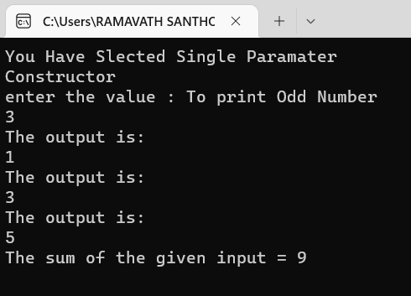

/*

Q8) Write a program using inline function inside and outside of the class (accessing data members

with objects and member functions)

*/

#include<iostream>

using namespace std;

class Sum

{

private :

int a,b;

public :

inline void add1(int c,int d)

{

a = c; b = d; cout << "\n The Sum using Inside inline function is " << a + b;

}

inline void add(int, int);

};

void Sum :: add(int x, int y)

{

a = x;

b = y;

cout << "\nThe sum of a = " << a << " and b = " << b << " using outside inline is " << a + b;

}

int main()

{

Sum o1;

int a, b;

cout << "\nPlease enter two integers 'a and b' : ";

cin >> a >> b;

o1.add(a,b);

o1.add1(a,b);

return 0;

}

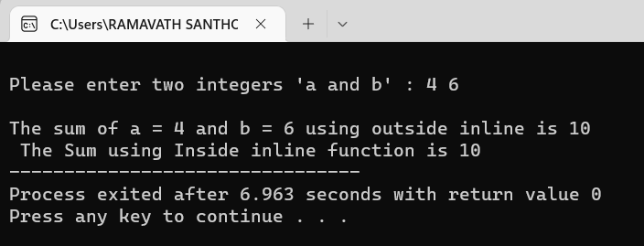

/*

Q9) Write a program to demonstrate the use of static data members

*/

#include<iostream>

using namespace std;

// suppose we want to count the number of objects created

class Status

{

public :

static int count; // only once created and common for all objects

Status()

{

count++;

}

};

int Status :: count = 0;

int main()

{

Status s1,s2,s3,s4,s5,s6;

cout << "\nThe number of objects created : " << s1.count;

return 0;

}

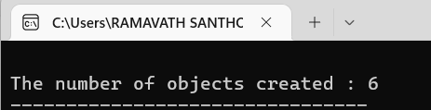

/*

An EMPLOYEE class is to contain the following data members and member functions: Data

members: EmployeeNumber (an integer), EmployeeName (a string of characters),

BasicSalary (an integer), All Allowances (an integer), IT (an integer), NetSalary (aninteger).

 Member functions: to read the data of an employee, to calculate Net Salary and to print the values of

all the data members. (AllAllowances = 123% of Basic; Income Tax (IT) = 30% of the gross salary (=

basic Salary +AllAllowance); Net Salary = Basic Salary + All Allowances – IT)

(Write program using constructors, destructors, static data members and static Member functions)

*/

#include<iostream>

using namespace std;

class Employee

{

public :

static int EmployeeNumber;

string EmployeeName;

int BasicSalary;

int AllAllowances;

int IT;

int NetSalary;

int GrossSalary;

int n;

Employee()

{

fflush(stdin);

cin.clear();

EmployeeNumber++;

cout << "\nPlease Enter Employee Number " << EmployeeNumber << " details...";

cout << "\nPlease enter the Employee Name : ";

getline(cin,EmployeeName);

cout << "\nPlease enter the Basic Salary : ";

cin >> BasicSalary;

}

void calculation()

{

AllAllowances = 1.23 * BasicSalary;

GrossSalary = AllAllowances + BasicSalary;

IT = 0.3 * GrossSalary;

NetSalary = BasicSalary + AllAllowances - IT;

}

void showDetails()

{

cout << "\nEmployee Name : " << EmployeeName;

cout << "\nBasic Salary : " << BasicSalary;

cout << "\nGross Salary : " << GrossSalary;

cout << "\nNet Salary : " << NetSalary;

cout << "\nIncome Tax : " << IT;

}

~Employee()

{

cout << "\nEmployee " << n << "'s Details Done";

}

};

int Employee :: EmployeeNumber = 0;

int main()

{

int n;

cout << "\nPlease enter the number of Employees : ";

cin >> n;

Employee E[n];

for(int i = 0; i < n; i++)

{

//E[i].getDetails();

E[i].n = i + 1;

E[i].calculation();

}

for(int j = 0; j < n ; j++)

{

cout << "\nEmployee Number : " << j + 1;

E[j].showDetails();

cout << endl;

}

}

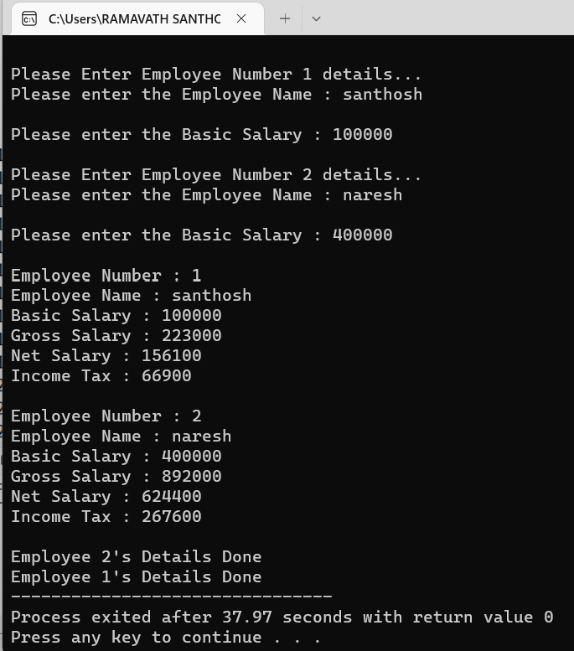

*********************************************END********************************************